Reverse Mortgage Social Media Post: How does a reverse mortgage work?
________________________________________________________________________________

Caption
In Canada, a reverse mortgage is a loan secured against your principal residence that gives you access to tax-free cash—with no ongoing mortgage payments.
Curious about how you can unlock financial peace of mind with a reverse mortgage?
Contact me at [your contact details] today.

Image
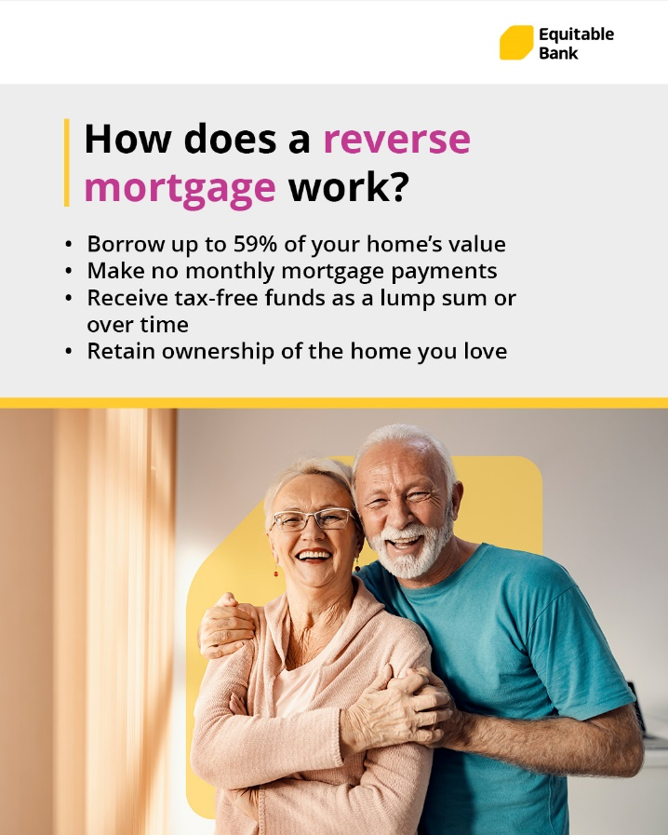

How to Post on Facebook
- Highlight, right-click, and press copy on the caption:

- Right-click and press save as picture on the image

- Login to your Facebook account and start a new post by clicking on ’What’s on your mind’

- Paste the caption. Don’t forget to add your contact information into the caption before posting

- Upload the image that you saved to the post

- Click Post

________________________________________________________________________________

How to Post on Instagram
- Highlight, right-click, and press copy on the caption

- Right-click and press save as picture on the image

- Login to your Instagram account and start a new post by clicking on the PLUS

- Upload the image that you saved to the post

- Click next and then next again

- Paste the caption. Don’t forget to add your contact information into the caption before posting

- Click Share

